 | Nancy Willis, Certified Pedorthist  Mobile Service: Kingston, ON  613.545.2367 or 866.683.8260  www.ceonancy.ca  ceo.nancy.willis@gmail.com

TIE ONE ON 101- LACING TECHNIQUES

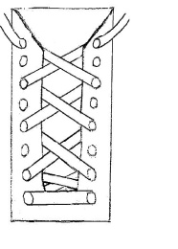 | Wide Feet  Use the eyelets that are closer to the tongue of the shoe. This will give more width to the lacing area.
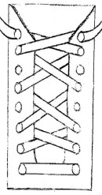 | Narrow Feet  Use the eyelets set wider apart on the shoe. This will bring the sides of the shoe more tightly across the top of the narrow foot.
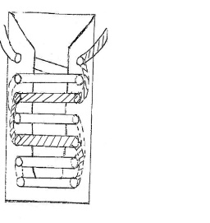 | High Instep  Lace the shoe so the laces travel in a straight line from eyelet to eyelet. This lacing pattern creates no pressure points at the laces.
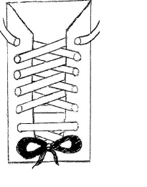 | Narrow Heel or Wide Forefoot  Use two laces to achieve a custom fit. Use one set of laces and the bottom two eyelets to allow for a wide forefoot. Use another set of laces and the remaining eyelets to tighten around a narrow heel.
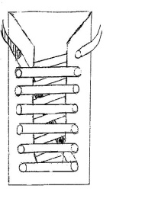 | Toe Problems  Lace the shoe so that the toe box is lifted by pulling on the lace that travels directly from the toe to the top of the shoe.
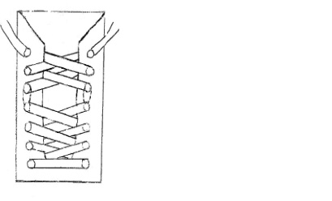 | Specific Pain  Lace the shoe using the criss-cross pattern, skipping the eyelets at the point of pain.
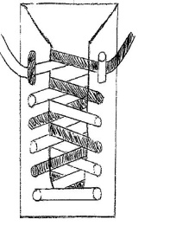 | Heel Fit  Lace the shoe using the criss-cross pattern. To tie the shoe, draw each lace up through the second last eyelet down into the last eyelet, making a loop to catch the lace from the opposite side.

